Week 2 - CSS Styling Portfolio Website

Introduction
For Week 2 of the Web Development Internship, I enhanced my Personal Portfolio Website by adding CSS styling and improving the overall user interface. The main objective of this task was to learn how CSS can be used to make a website visually appealing, responsive, and user-friendly.
I used an external CSS file to style the website and applied modern design principles such as Flexbox layouts, custom colors, hover effects, responsive design, and typography improvements.

What I Learned
While working on this project, I learned:
- CSS selectors (Element, Class, and ID selectors)
- CSS properties such as color, background, margin, padding, border, and font styling
- CSS Box Model
- Flexbox layout system
- Hover effects and transitions
- Responsive web design using media queries
- Using Google Fonts
- Organizing styling using an external CSS file

Improvements Made from Week 1
The Week 1 website contained only an HTML structure without styling.
In Week 2, I added:
- Professional color scheme
- Improved typography using Google Fonts
- Responsive navigation menu
- Styled About section
- Skill badges with hover effects
- Project cards layout
- Styled contact form
- Mobile responsive design
- Better spacing and alignment

Website Sections

Header Section
The header contains my name, role, and a short introduction. Custom colors and typography were used to improve the visual appearance.

Navigation Bar
The navigation menu allows users to quickly move between sections. Hover effects were added for better user interaction.

About Section
This section contains my profile image and a brief introduction about my academic background and interests.

Skills Section
Technical skills are displayed using styled skill badges created with CSS.

Projects Section
Project information is displayed using card-based layouts with spacing and visual styling.

Contact Section
A styled contact form was created with input fields, labels, and a submit button.

Technologies Used
- HTML5
- CSS3
- Visual Studio Code
- Google Chrome

CSS Concepts Used

CSS Selectors
Used different selectors, including:
- Element Selector
- Class Selector
- ID Selector

Flexbox
Flexbox was used for:
- Navigation alignment
- About the section layout
- Skills section arrangement
- Project cards layout

Hover Effects
Hover effects were applied on:
- Navigation links
- Buttons
- Skill badges
- Project cards

Media Queries
Media queries were implemented to ensure the website works properly on mobile devices and smaller screens.

Project Folder Structure
PortfolioWebsite/
├── index.html
├── style.css
├── README.md
├── images/
│ └── profile.jpg
└── screenshots/
├── home-page.png
├── about-section.png
├── projects-section.png
├── contact-section.png
└── mobile-view.png

How to Run the Project
- Download or clone the repository.
- Open the project folder in VS Code.
- Ensure that index.html and style.css are in the same directory.
- Open index.html in a web browser.
- The website will load with all CSS styling applied.

Technical Requirements Completed
✔ Created external style.css file
✔ Used multiple CSS selectors
✔ Added custom color scheme
✔ Added Google Fonts
✔ Implemented hover effects
✔ Used Flexbox layout
✔ Created responsive design
✔ Added media queries
✔ Styled forms and buttons
✔ Added mobile-friendly layout

Testing Evidence

Desktop Testing
The website was tested on Google Chrome in desktop view. All sections, including About, Skills, Projects, and Contact, are displayed correctly. Navigation links worked properly, and the layout remained consistent throughout the page.

Mobile Testing
The website was tested using browser developer tools in responsive/mobile view. The navigation menu adjusted properly for smaller screens, content remained readable, and all sections were accessible without layout issues.

Form Testing
The contact form was tested to verify that the Name, Email, and Message fields function correctly. Input fields are properly aligned, and the submit button is displayed correctly.

Functionality Verification
✔ Internal navigation links tested successfully
✔ Hover effects tested on navigation links, buttons, and skill badges
✔ Responsive layout tested on different screen sizes
✔ Images loaded correctly without errors
✔ Project cards displayed properly using Flexbox layout
✔ Website tested in Google Chrome browse
Screenshots
Insert the following screenshots:
- Full Homepage Screenshot
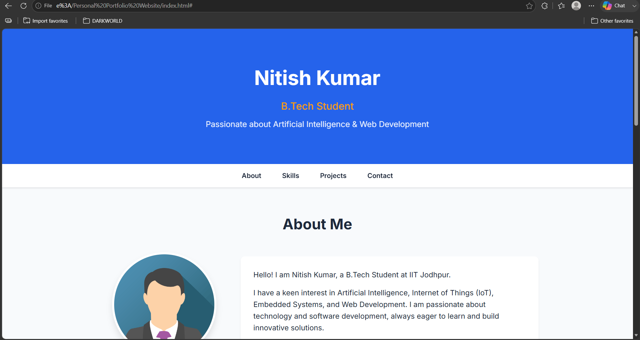

- About Section Screenshot
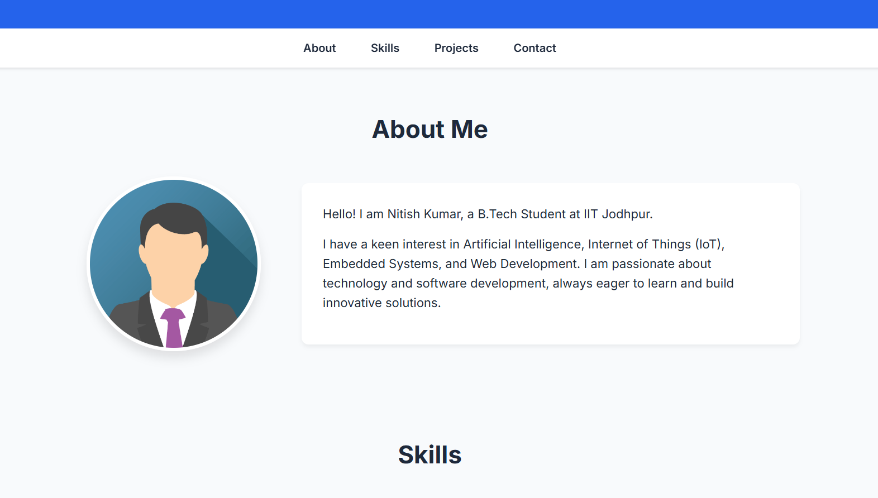

- Skills Section Screenshot

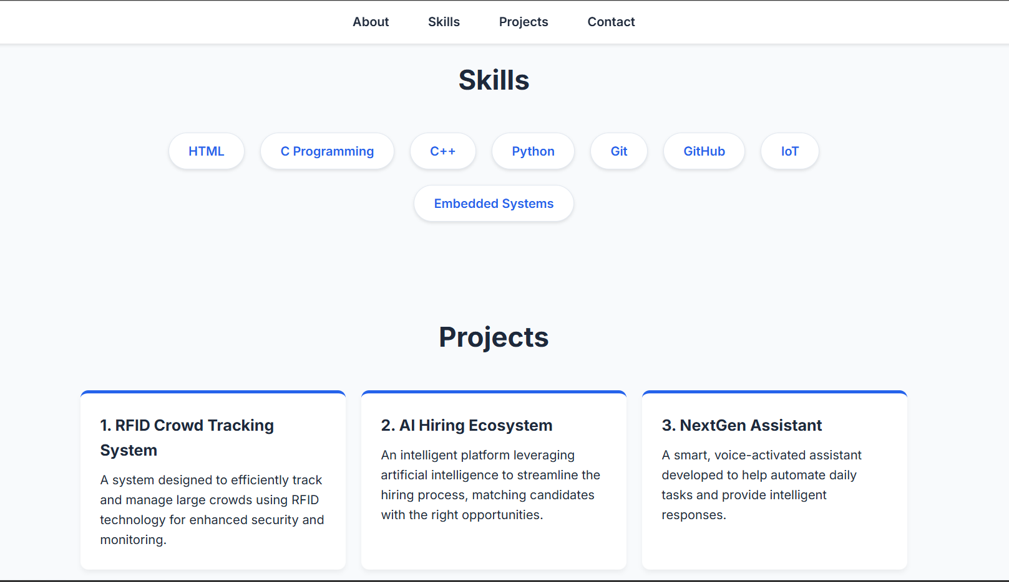
- Projects Section Screenshot
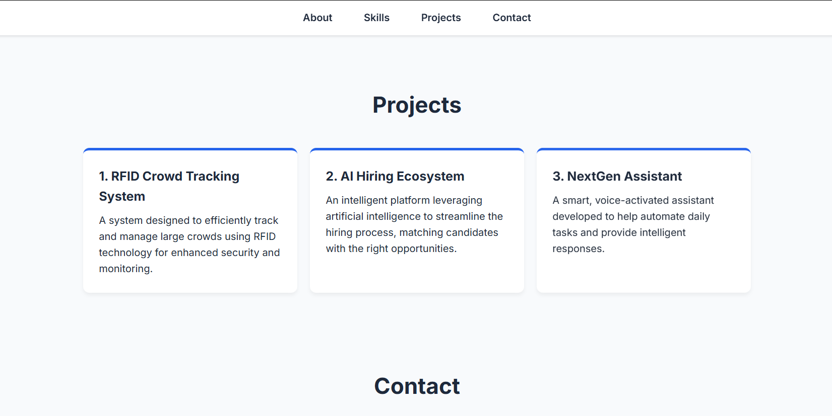
- Contact Form Screenshot
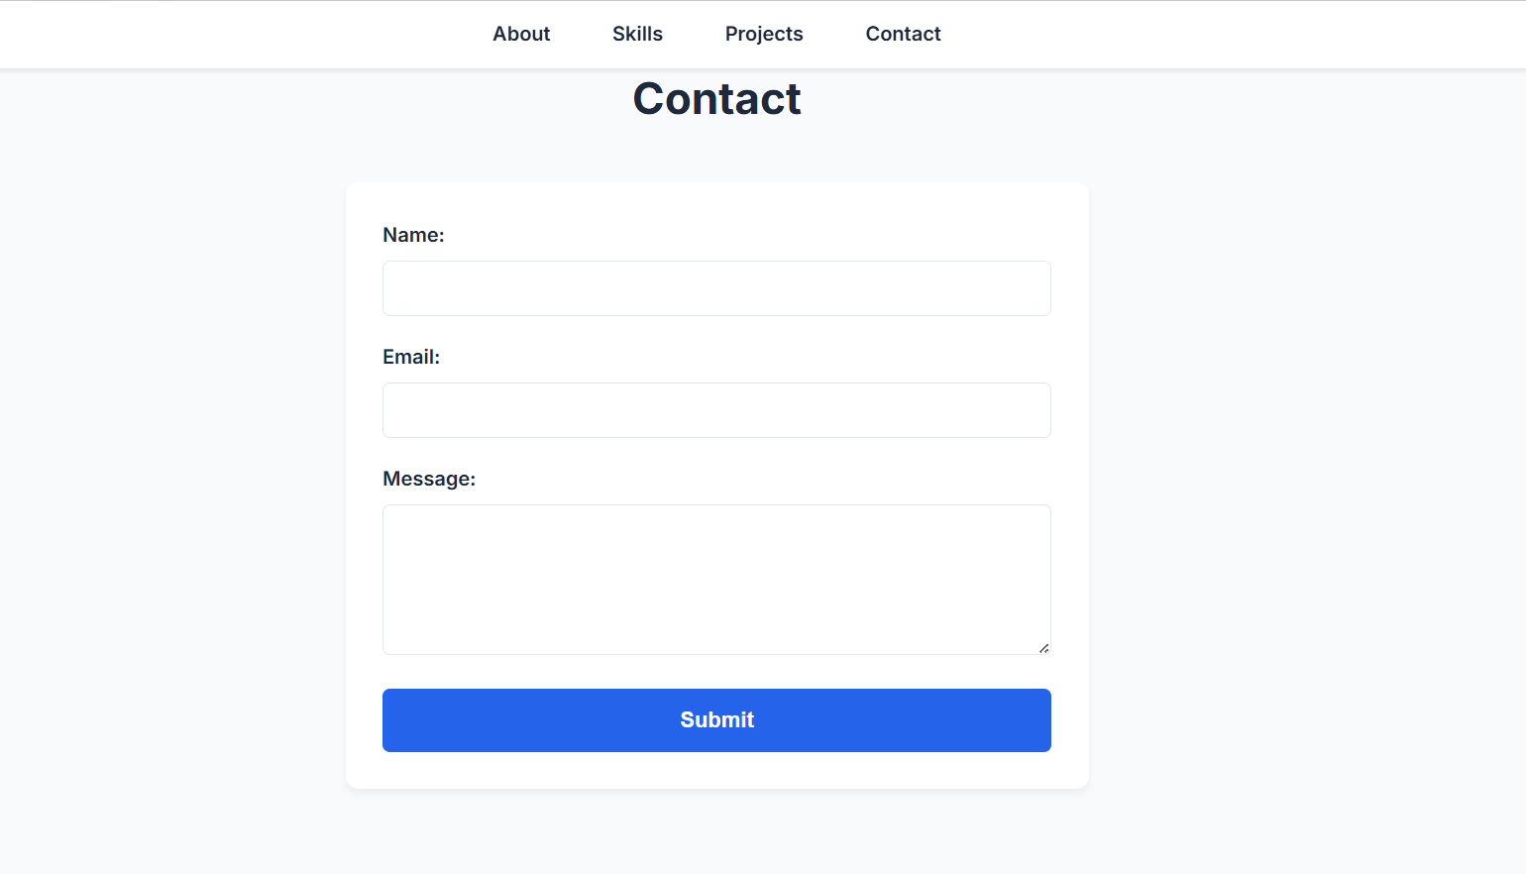
- Mobile Responsive View Screenshot
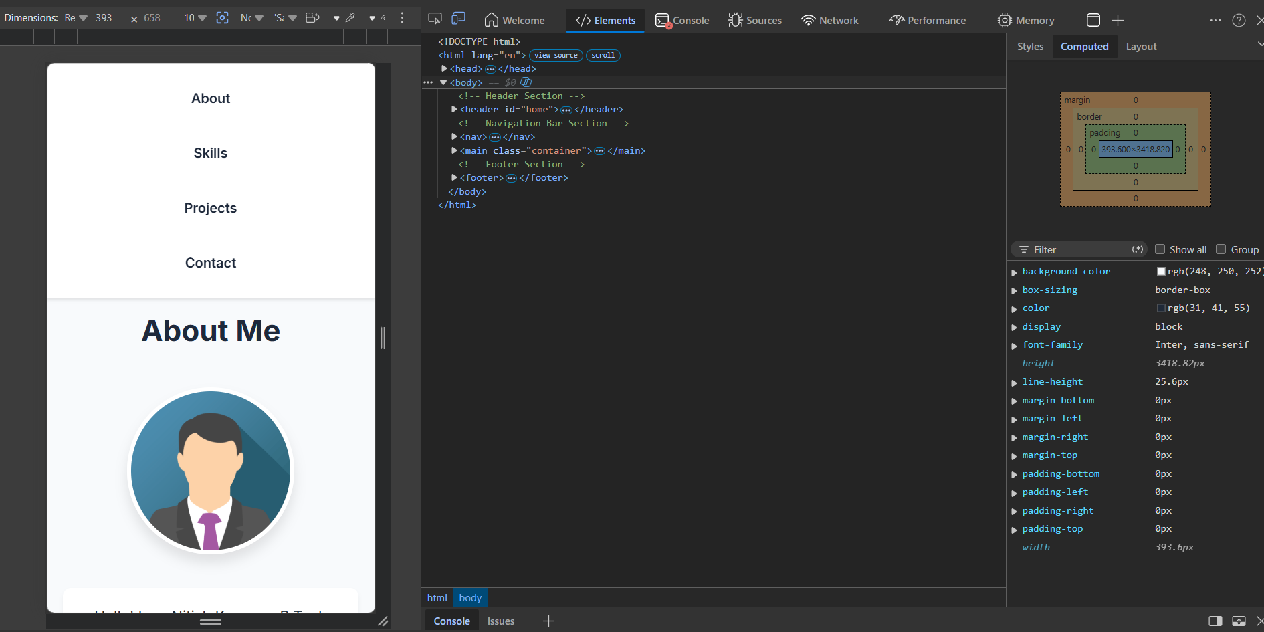

Conclusion
This project helped me understand how CSS improves the appearance, usability, and responsiveness of a website. Through this assignment, I gained practical experience in styling web pages, creating responsive layouts, and applying modern web design techniques.

